“I believe that American Agriculture can and will hold true to the best traditions of our national life and that I can exert an influence in my home and community which will stand solid for my part in that inspiring task.” – E.M. Tiffany FFA Creed  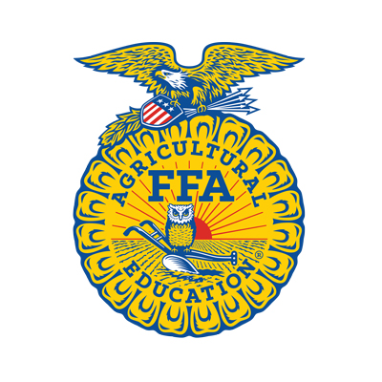 | Contact Information:  Joe Keller  608-963-2408  Greg Markley  608-381-0384  Tim Lins  608-370-4343  Email: kellerproduce@frontier.com  Mail to: Joe Keller, N1155 St Rd 188 Prairie du Sac, WI 53578  Please make checks payable to Sauk Prairie FFA Alumni and note Fences Among Friends in the Memo.  Thank you! |  | Fences Among Friends  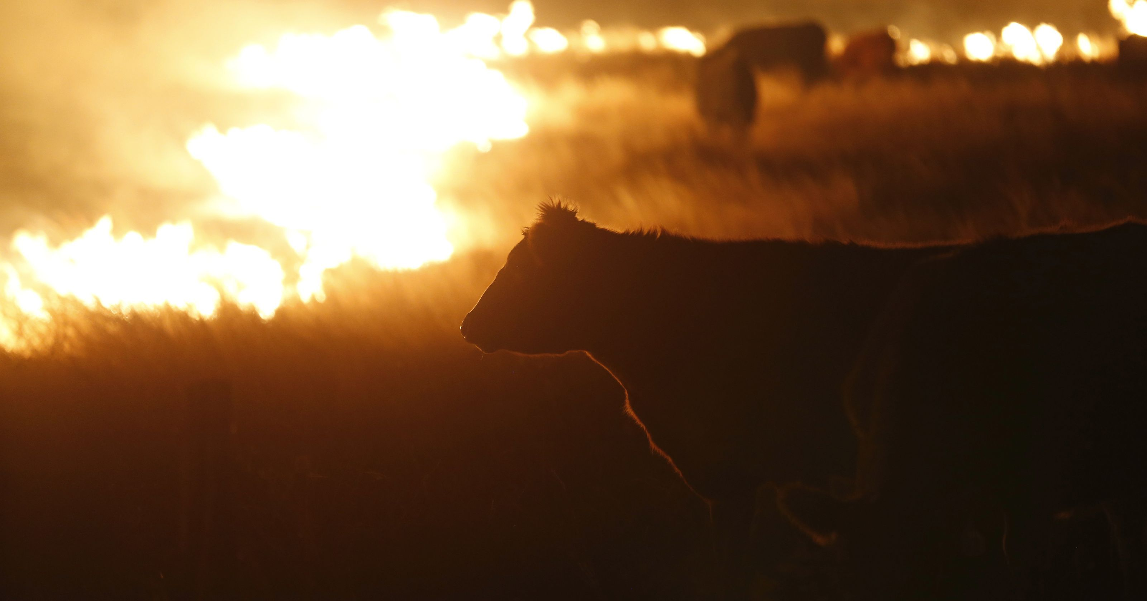  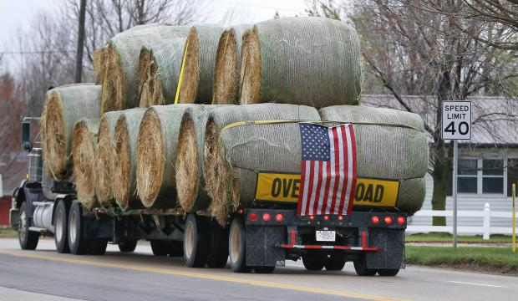

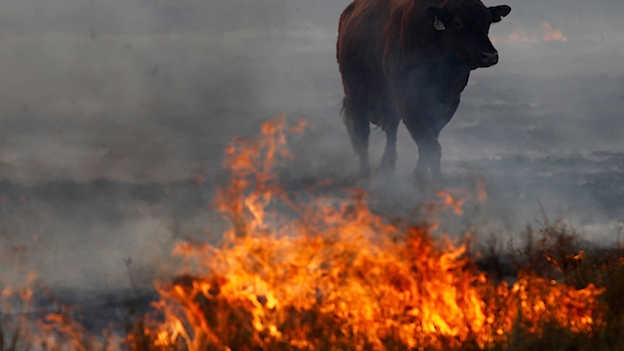  What happened?  In early March, wind driven wildfires raced through the Southern Plains leaving mass destruction in their wake. Many communities were left with nothing- no livestock, no barns, no homes, and for some- no loved ones. Over 1,500,000 acres were burned in the mass tragedy wiping out family farms.  Farmers and Ranchers had no time to rest. Hours after fires ravaged their homesteads, they were out searching for wounded and dying livestock to end their suffering. More than 10,000 cattle were lost, along with 9,000 hogs, countless homes, equipment, feed stocks, and hundreds of miles of fencing. | The stock that survived struggled to find feed. American farmers banded together and sent convoys of hay and feed from all over the United States. Although this has helped immensely, there are still needs. 85% of the land mass of Clark County, Kansas was scorched. They have an estimated 12,000 miles of fencing that need to be repaired or replaced. The community is in need of your help!  How can I help?  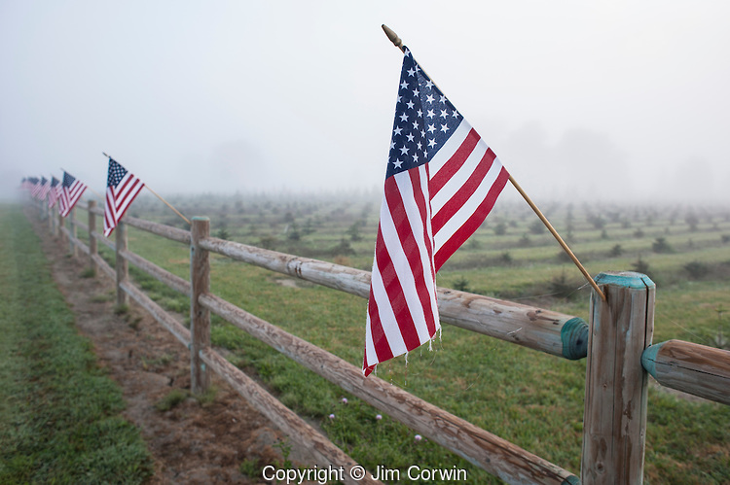  Please consider making a donation to help the Sauk Prairie FFA Alumni cover the cost. The chapter is planning to send at least one semi-load of fencing to our friends in Ashland, Kansas. The load will build about 10 miles of fencing. Our goal is to raise $25,000 to cover the cost of the materials. | Donations can be dropped off at one of the following collection points:  - Eagle Valley Ag Service  - Wyttenbach Meats  - Rainbow Floral  - McFarlanes  - Sauk Prairie Community Bank  In order to provide the immediate help Ashland needs, all donations must be collected no later than April 18th.  